18/10/2026 NAME: Charulatha.V
Experiment :4 REG.NO.:192424031
SLOT: A
SEMESTER:MS2 September 2026
COURSE CODE:CSA4701
COURSE NAME:Deep Learning

Entropy, Cross-Entropy and KL Divergence
Scenario:
A decision-support system classifies transactions into three risk categories: Low, Medium, and High. Calculate entropy to measure uncertainty, cross-entropy to evaluate prediction quality, and KL divergence to measure the difference between actual and predicted distributions.
Algorithm:
- Start the program.
- Import NumPy, SciPy, and Matplotlib libraries.
- Define the actual and predicted probability distributions for Low, Medium, and High risk categories.
- Calculate entropy using the predicted probability distribution.
- Calculate cross-entropy between the actual and predicted distributions.
- Calculate KL divergence to measure the difference between the two distributions.
- Display the calculated entropy, cross-entropy, and KL divergence values.
- Plot a bar chart to compare the actual and predicted probabilities.
- Display the graph and interpret the results.
- Stop the program.
Source code:

import numpy as np
from scipy.stats import entropy
import matplotlib.pyplot as plt

# Actual and predicted probability distributions
actual = np.array([0.5, 0.3, 0.2])
predicted = np.array([0.6, 0.25, 0.15])

categories = ["Low Risk", "Medium Risk", "High Risk"]

# Calculate entropy
H = entropy(predicted, base=2)

# Calculate cross-entropy
cross_entropy = -np.sum(actual * np.log2(predicted))

# Calculate KL divergence
kl_divergence = entropy(actual, predicted, base=2)

# Display results
print("Actual Probabilities:", actual)
print("Predicted Probabilities:", predicted)

print("\nEntropy:", round(H, 4), "bits")
print("Cross-Entropy:", round(cross_entropy, 4), "bits")
print("KL Divergence:", round(kl_divergence, 4), "bits")

# Plot probability distributions
x = np.arange(len(categories))
width = 0.35

plt.figure(figsize=(8, 5))
plt.bar(x - width/2, actual, width, label="Actual")
plt.bar(x + width/2, predicted, width, label="Predicted")

plt.xlabel("Risk Categories")
plt.ylabel("Probability")
plt.title("Actual vs Predicted Risk Distribution")
plt.xticks(x, categories)
plt.legend()
plt.grid(axis="y", alpha=0.3)
plt.tight_layout()
plt.show()

# Result
print("\nRESULT")
print("Entropy, cross-entropy and KL divergence")
print("were calculated and visualized successfully.")
Output:
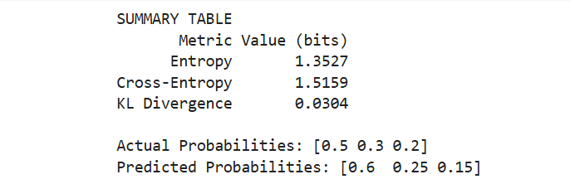
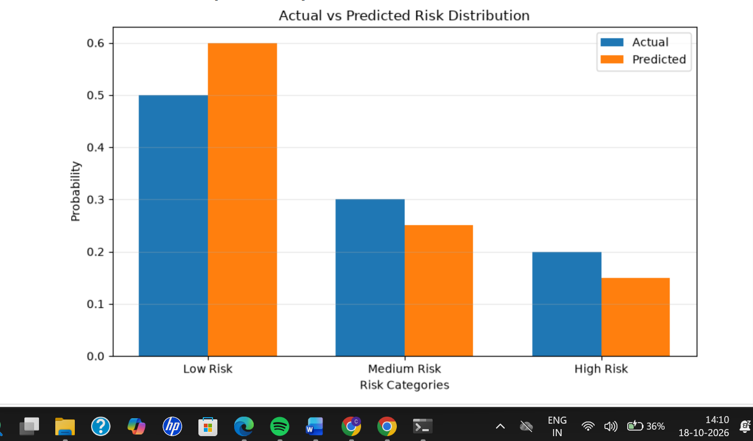
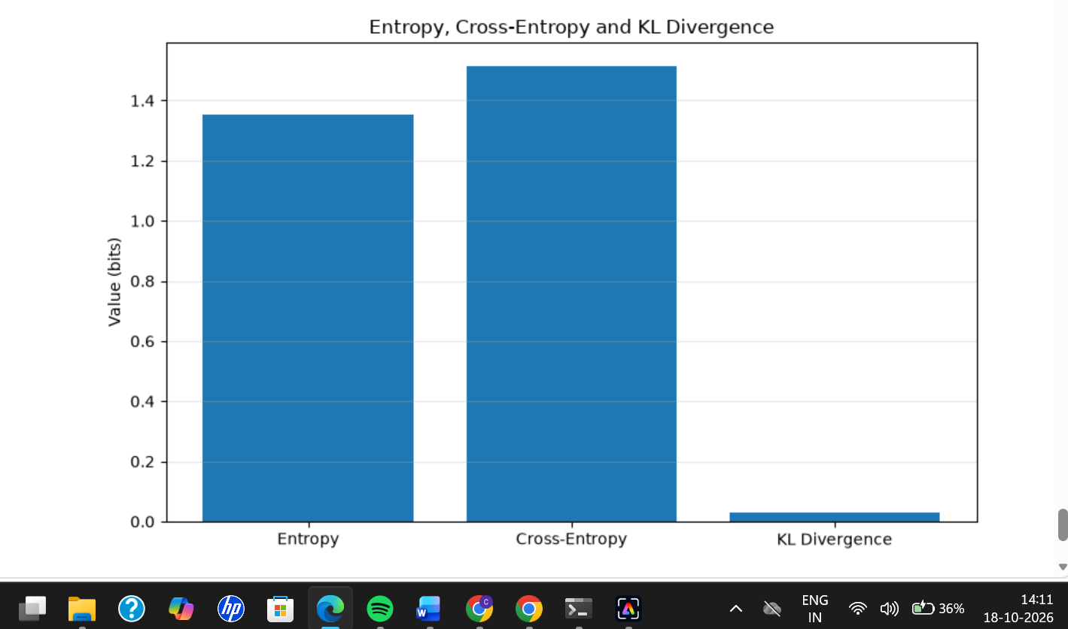

Result:
Thus, entropy, cross-entropy, and KL divergence were successfully calculated using NumPy and SciPy. Matplotlib was used to visualize the actual and predicted risk distributions. The low KL divergence value indicates that the predicted distribution is relatively close to the actual distribution.

